IIIT Ranchi Event Management site

1. Introduction

* *ORGANISER PORTAL* :Through this site organisers can promote their events/contests.
* *USER PORTAL* :Users can view events ( sorted by running-upcoming-past ) and can register for them and can view stats though dashboard.

*.*

* *ADMIN PORTAL* :Through admin portal admin can mark or delete any event . Admin have also access to details of all the organisers and users registered in the database.
* *GUEST PORTAL* : users can also see details of events without signup/signin.

2. Design and Implementation.

* This site is built using bootstrap4 using bootstrap css and js classes along with JQuery 3.5.1 plugin.
* Backend is implemented through php.
* Database : Mysql
* Hosting platform : “ 000webhostapp.com“
* Unique visitor count is also added at the bottom of the index.html.
* A comment section is also added for each event so that users can easily communicate with organisers and can solve their queries with organisers/admin/other users.



* Below are some screenshots of my project :

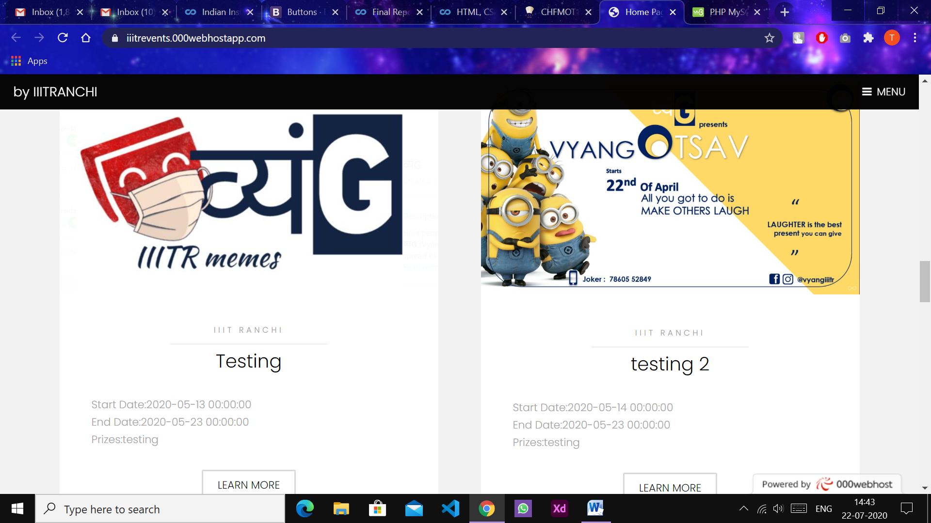

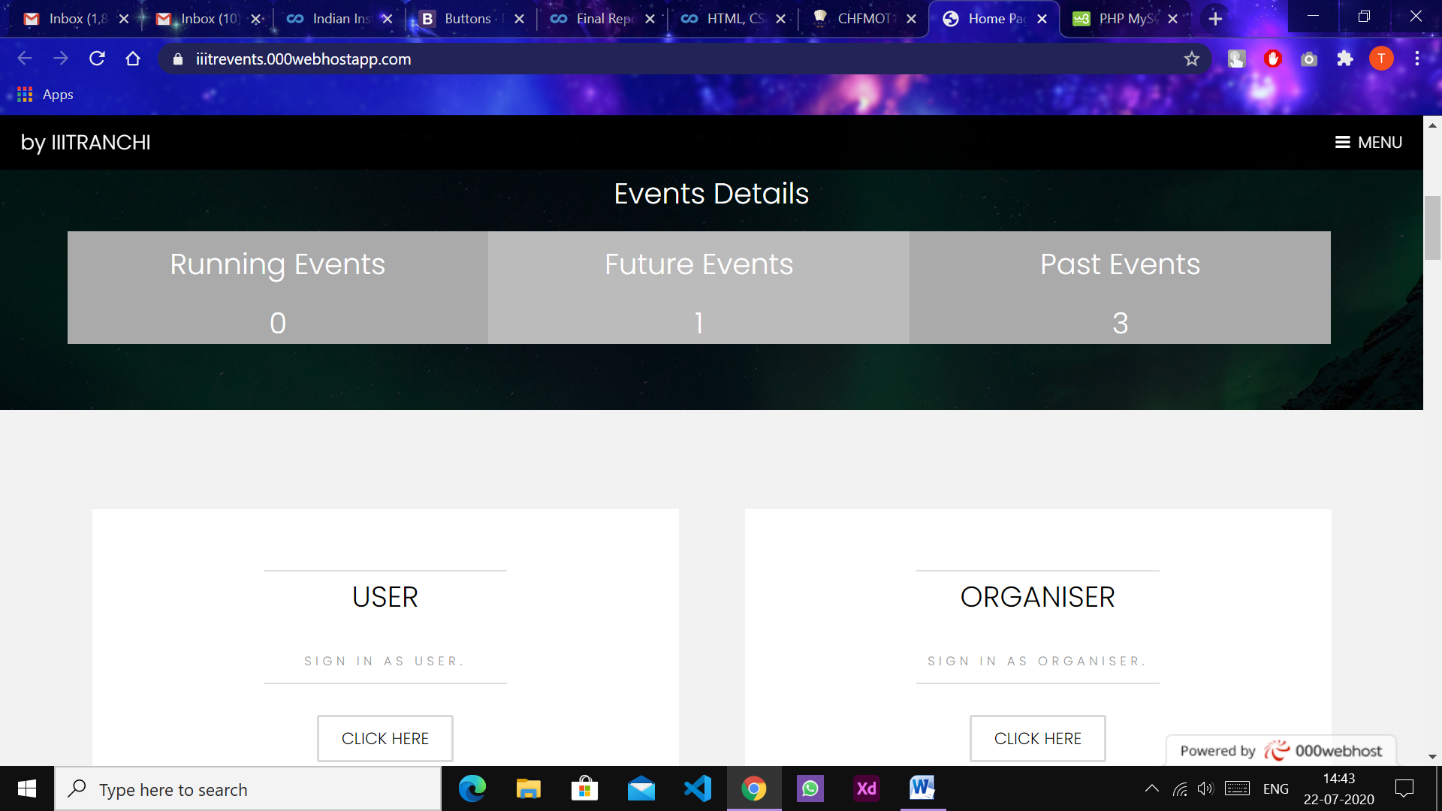

3. Conclusions

* Bootstrap made it very easy to keep the front-end mobile or small screen ready without bothering about it much.
* Short coming of the project : exception handling testing work is pending in the project as of now.
* I’ve planned to make a chat feature between organisers and admin just like comment section but it will be private . And a feature to allow admin to terminate anyone’s account.

### 4. References

* **Project link :** [**https://iiitrevents.000webhostapp.com/**](https://iiitrevents.000webhostapp.com/)
* **Source Code :** [**https://github.com/RishavMz/Hackovid**](https://github.com/RishavMz/Hackovid)
* <https://getbootstrap.com/>
* <https://www.w3schools.com/php/default.asp>
* <https://in.000webhost.com/>